Lab Task for Analysis of Algorithm
Name:Umar Ahad Uddin Ahmed Usmani
SAP :60199

Task 1 :
In Linear search they run the all loop in wrost case as proof that they have o (n)
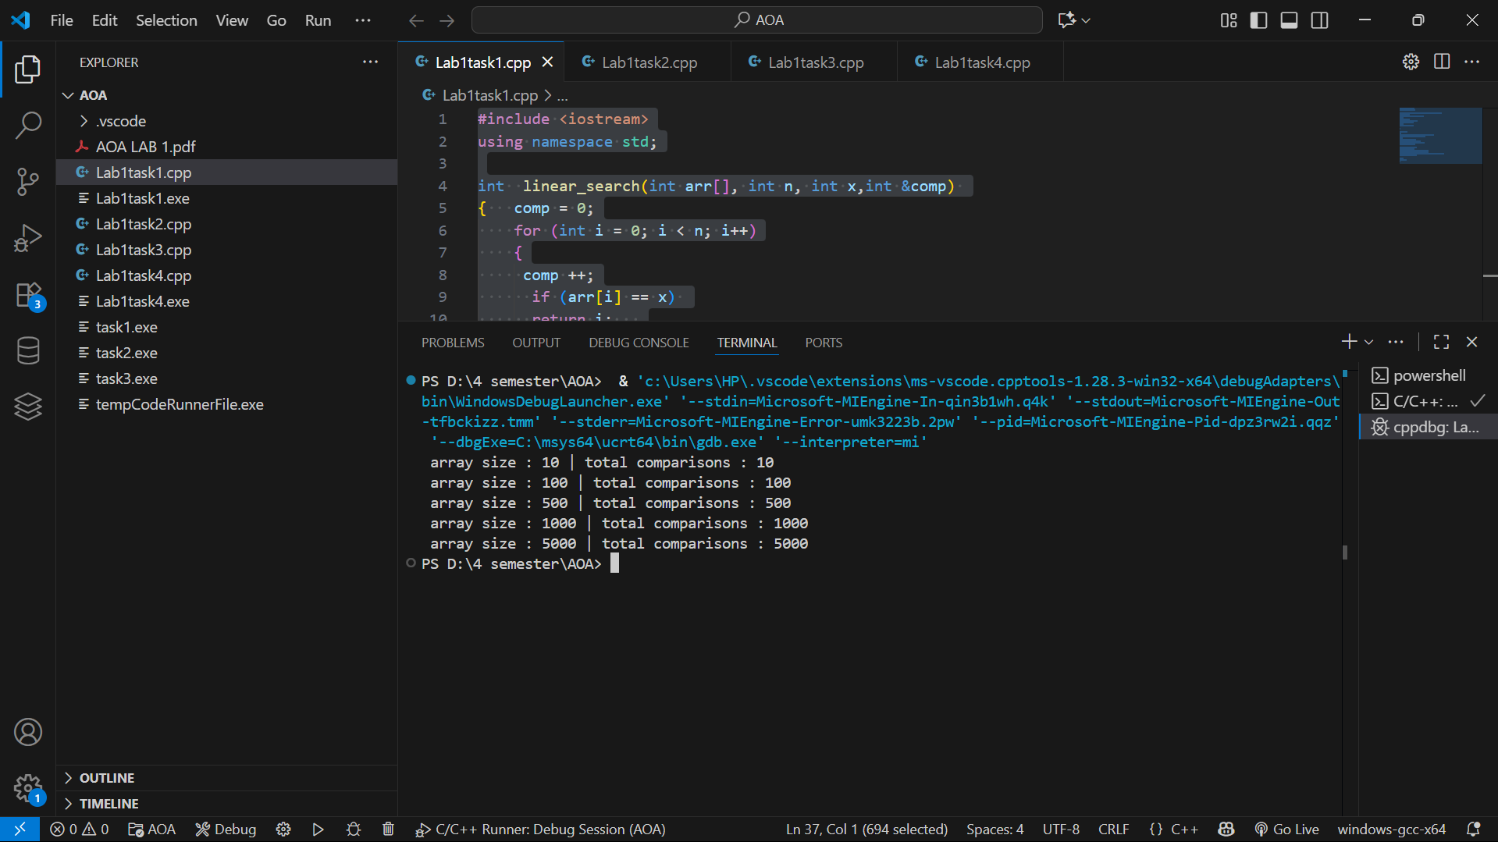

Task 2:
In binary search they run the loop in log time as o n log(n)
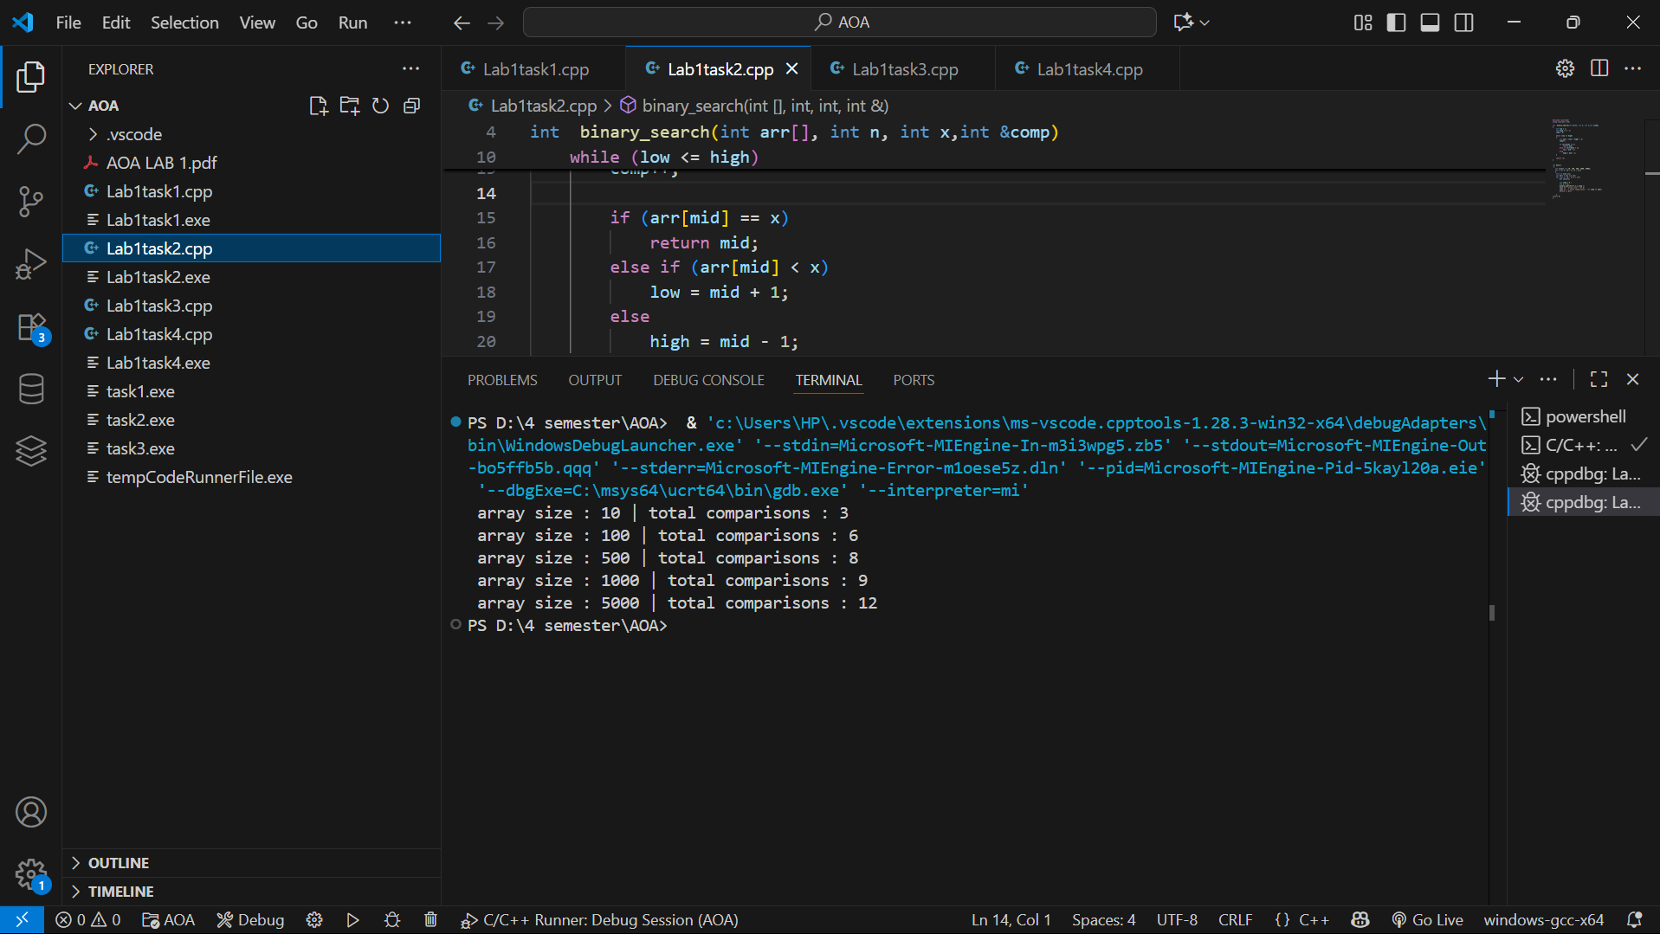

Task 3 :
In this we compare both linear search and binary search
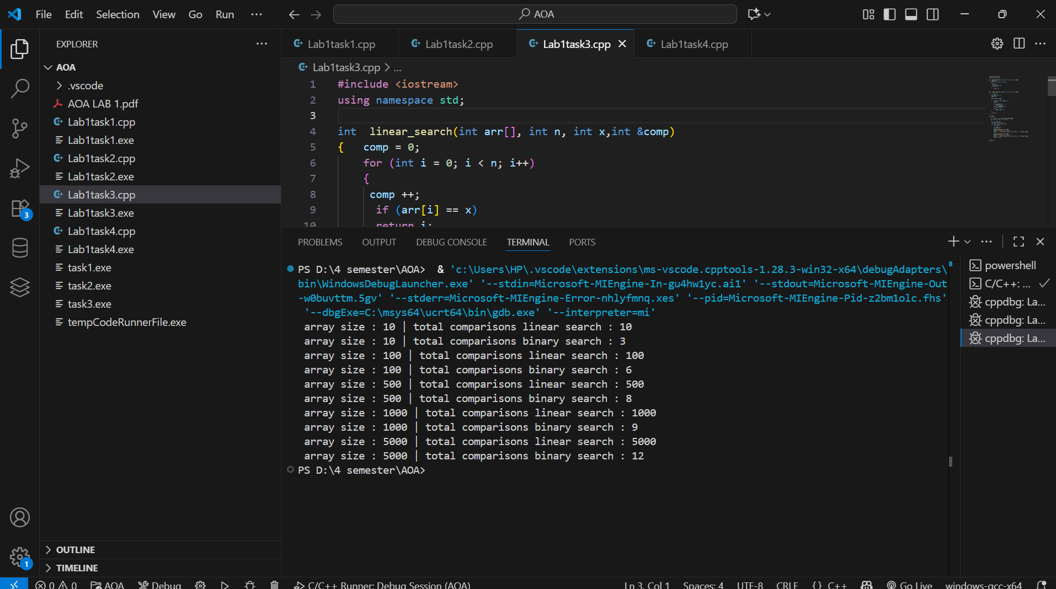

Task 4 :
In this we show the time complexity as o (n²)

